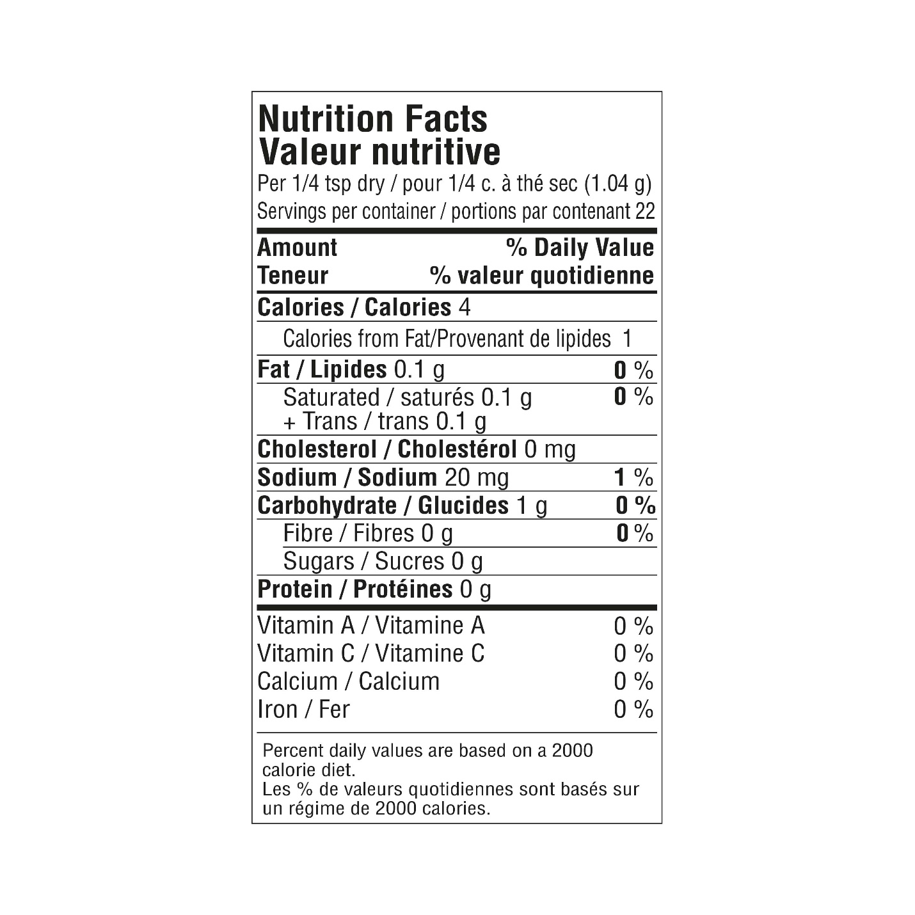

INGREDIENTS: CHEDDAR CHEESE POWDER FLAVOUR (**MILK**, SALT), GARLIC, ONION, GREEN ONION SPICES, SMOKE FLAVOUR. **CONTAINS MILK AND SOY**.